**Islamabad:**

Rawal Lake

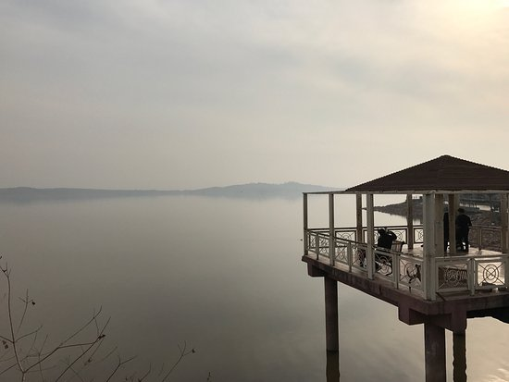

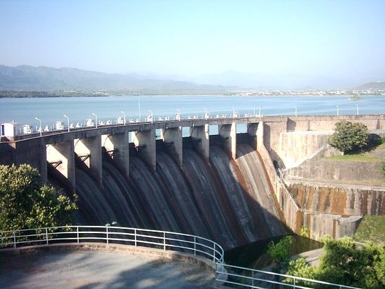

**Rawal Lake** in Pakistan is an artificial reservoir that provides the water needs for the cities of Rawalpindi and Islamabad. Korang River along with some other small streams coming from Margalla Hills have been set to form this artificial lake which covers an area of 8.8km². Korang River is the outlet stream of Rawal Dam. Rawal Lake is located within an isolated section of the Village Malpur, Bani Gala and Margalla Hills National Park. The area around the lake has been planted with flowering trees and laid out with gardens, picnic spots, and secluded paths. The terraced garden and the lake are used for picnics, fishing and boating. The highest point in the garden offers a panoramic view of the lake, Margalla and Murree hills, Rawalpindi and Islamabad.